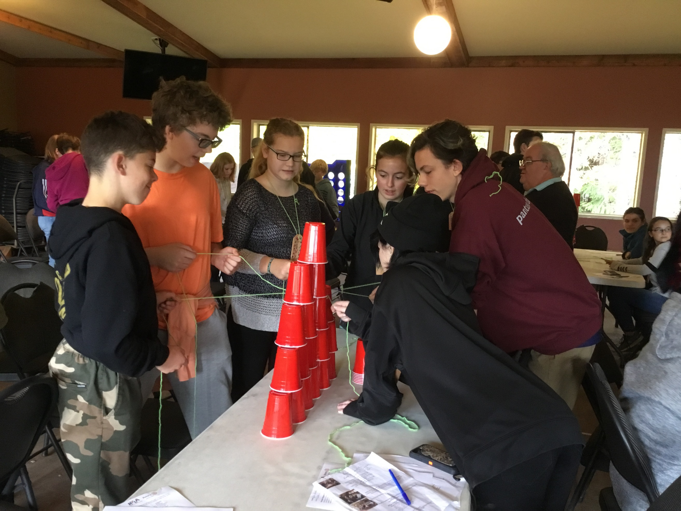

Accommodations are in lodges, up

to 7 participants per room.

Females and males on separate floors.

Adult supervision.

Participants will need to bring their

own bedding and toiletries.

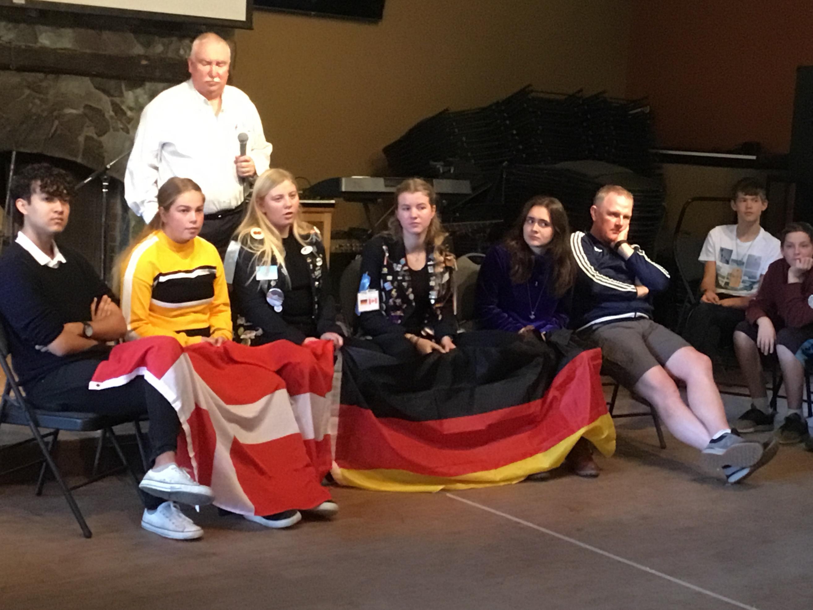

For all forms: application, consent form, packing list, leaders application: Contact RYLA VI registrar Joan Ryan: [jmrnewfoundland@gmail.com](mailto:jmrnewfoundland@gmail.com)

**All student expenses associated with this event are supported by the student’s local Rotary Clubs**.

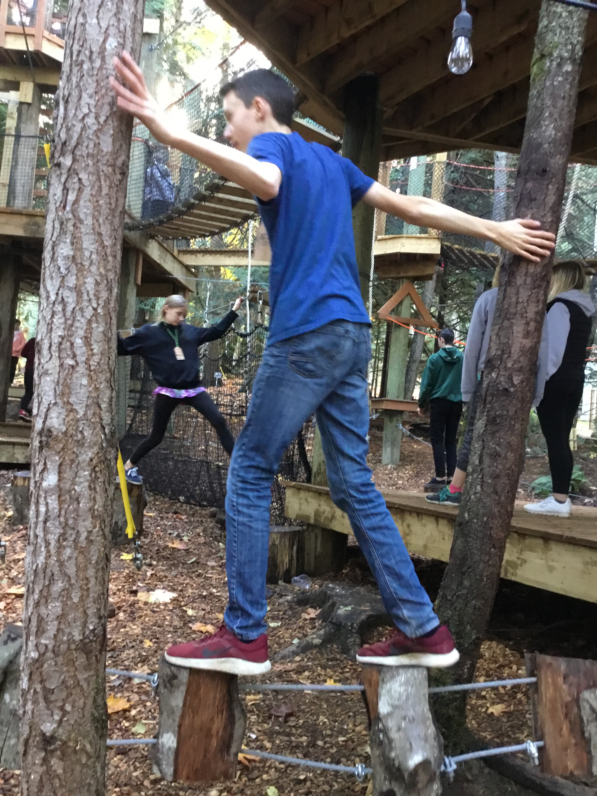

**A leadership training weekend for youth from grades 8 to 10 from Washington State and Vancouver Island in**

**Rotary District 5020.**

**For brochures, application forms, other information go to:**

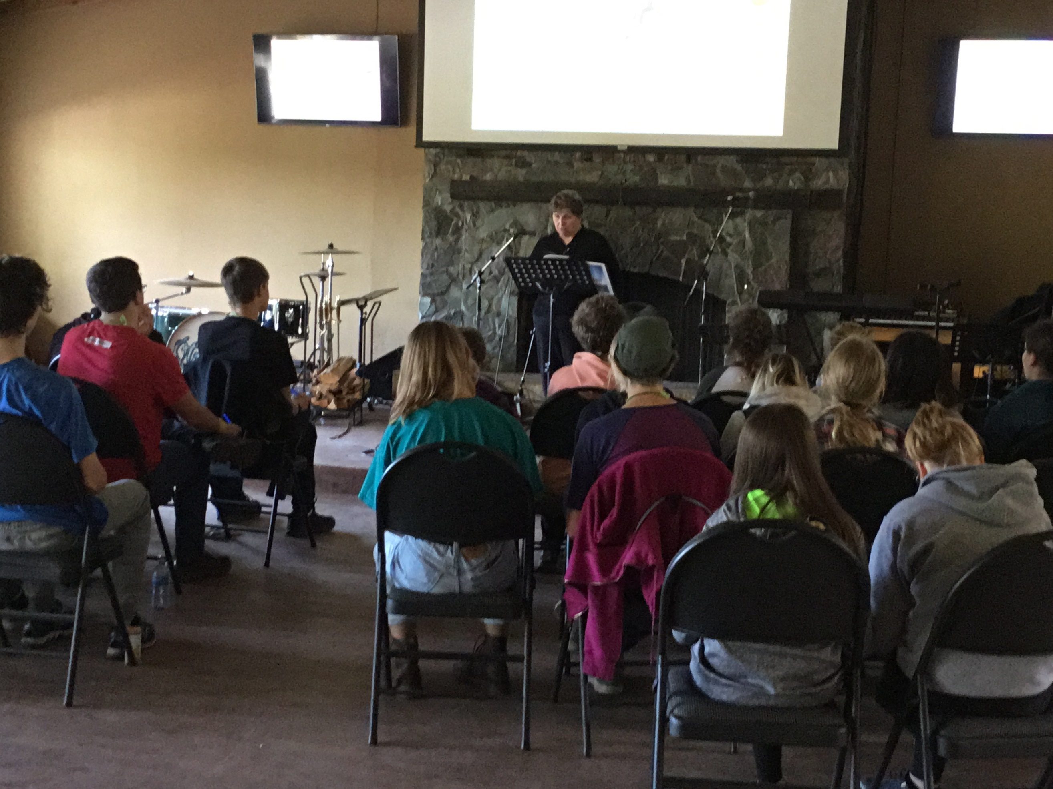

**Rotary International**

**District 5020**

[](http://www.google.ca/url?sa=i&rct=j&q=&esrc=s&source=images&cd=&cad=rja&uact=8&ved=0ahUKEwij8Iuu48bOAhVS92MKHQ_gC7IQjRwIBw&url=http://www.rotarydistrict3310.org.my/index.php/2016/04/ryla-pontian-2016-district-3310/&psig=AFQjCNEg6Wo12av3VrqJV66I7Kr_DcglwQ&ust=1471465421363702)

**VANCOUVER ISLAND 2022**

**ROTARY**

**YOUTH**

**LEADERSHIP**

**AWARDS**

**November 18-20, 2022**

**Camp Qwanoes**

**1148 Smith Road, Crofton, BC, V0R 1R0**

We are pleased to offer

ryla Vancouver island

#5

**Registration Deadline**

**November 6, 2022**

**Friday, November 18, 2022**

11:00 – 12:30

Registration; room, assignments,

sports activities

12:30-1:15 lunch

1:30-2:45 **What makes a leader?**

Michael Furlot, Rotarian

2:45-3:15 snack and activity break

3:15-3:45 **Polio Plus and Beyond**

Cheryl Leukefeld, Rotarian

3:45-5:00 Stephen & Brian

Team building/Initiative tasks

5:00 – 5:15 settling in getting to know

your cabin mates

5:15 **Welcome by**

**First Nations Elder**

5:30-6:15 Dinner

6:30-7:30 **First Nations Panel**

Indigenous people from various tribes.

**7:30-7:45 activity break**

7:45-9:00 Stephen Cochrane

9:00-9:30 Getting acquainted

Opportunity for anybody who has musical instruments to practice together.

9:30-10:00 Team Time

10:30 Lights Out

[](http://www.google.com/url?sa=i&rct=j&q=&esrc=s&source=images&cd=&cad=rja&uact=8&ved=0ahUKEwjKuKzx8JbOAhUUSGMKHcTuArUQjRwIBw&url=http://www.underconsideration.com/brandnew/archives/new_logo_and_identity_for_rotary_by_siegelgale.php&psig=AFQjCNHKsVnQOfvg5BebXQ2p0AUNR_bdsA&ust=1469820147206669)

**Saturday, November 19, 2022**

8:00-8:45 Breakfast

8:45-10:45 **Social Styles Awareness**

*Learn to identify the traits you were born with.*

Joan Ryan, Rotarian

10:45-11:15

Break and activity

11:15-12:30 **Self-Empowerment**

*Where excellence in leadership begins.* Christina de Souza

12:30-1:15 lunch

1:30-2:45 Stephen Cochrane & Brian Mather

Team building/Initiative tasks

2:45-4:15

**The Gift of Rotary Youth Exchange**;

4:15-5:15 talent show

5:30-6:15 Dinner

6:30-7:30 Rehearsals

7:30-9:30

4-Way Test Skits,

9:30-10:00

Team Time

10:30

Lights Out

Tech support for the weekend is

Troy Dejong, Rotary Club of Lantzville.

[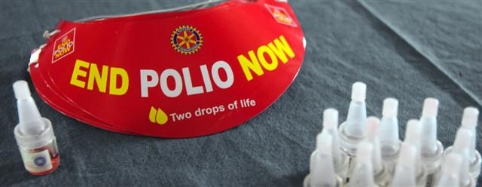](http://www.google.com/url?sa=i&rct=j&q=&esrc=s&source=images&cd=&cad=rja&uact=8&ved=0ahUKEwjPqJ-28ZbOAhVKyGMKHbPEBMIQjRwIBw&url=http://www.rotarylebanonmo.com/Pages/PolioPlus.aspx&bvm=bv.128153897,d.cGc&psig=AFQjCNHPi1jGkcjt6UUOPlzcLQzjSG1iHw&ust=1469820260308130)

**Sunday, November 20, 2020**

8:30-9:15

Breakfast

9:15-9:45

Pack up and vacate rooms

9:45-10:45

**Closing Ceremony**, group photos, etc.

11:00 Departure Time

YOUR **RYLA VI** TEAM:

Participants will be assigned to a team for the weekend, every effort will be made to ensure teams include youth from various communities and if possible both countries.

(Canada and the United States)

During the weekend the teams will get to know one another, explore ideas together and create a painting that will become part of a larger collage at the closing ceremony.

[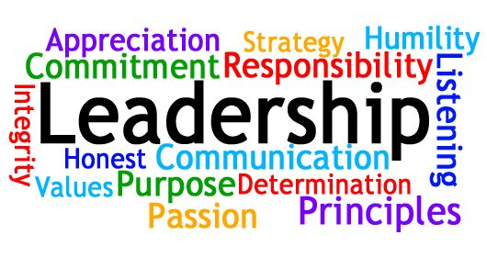](https://www.google.com/url?sa=i&rct=j&q=&esrc=s&source=images&cd=&cad=rja&uact=8&ved=0ahUKEwjQ_Kny8ZbOAhVE3mMKHeMEB0QQjRwIBw&url=https://www.pinterest.com/jenpirates28/youth-ministry-student-leaders/&bvm=bv.128153897,d.cGc&psig=AFQjCNE4t1ut9gEMy_PahUOY5wuOgr3Iaw&ust=1469820372898179)